BS – Important Concepts Normal Distribution – Lessons 18, 19

- Probability Density Function (PDF):
→ In a normal distribution, by knowing where on the x-axis the value falls, in terms of standard deviation, we can determine the percentage less than or greater than any value
→ use theoretical curve to model the data;
→ the area under the curve is 1 because it models the relative frequency of a distribution of data in terms of proportions;
→ the curve is called the probability density function, PDF;
→ the area underneath the curve represents the probability;
→ we can visually model statistical concepts;
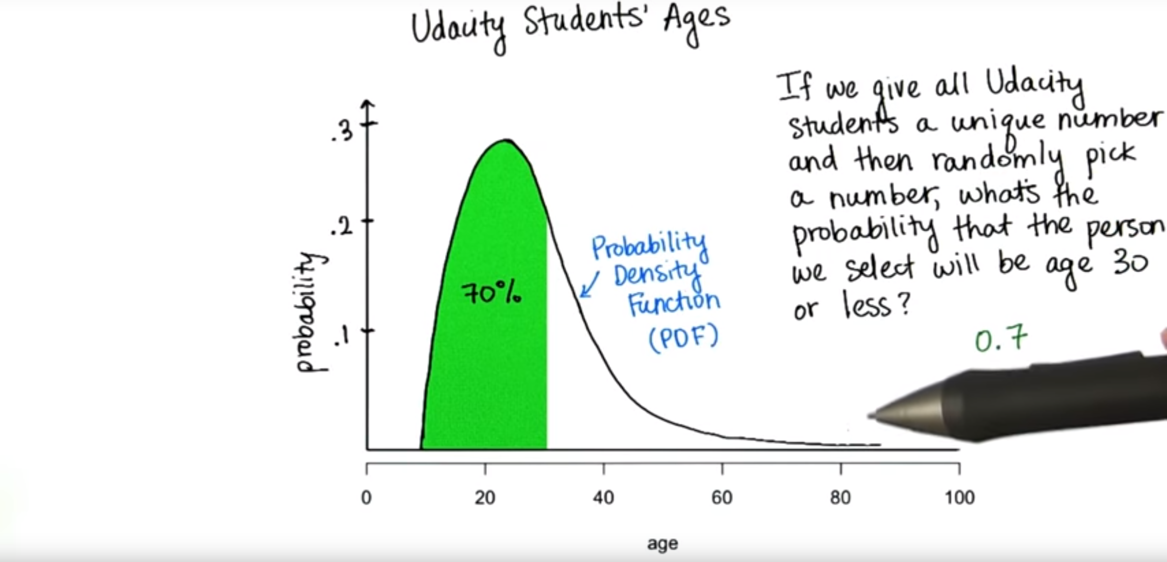

- Normal distributions:
→ are modeled by a special probability density function;
→ we can model the curve with an equation and use calculus to find the area under the curve;
→ Z-table to figure out the area under the curve, between any of two values;
→ the tales never actually touch the x-axis because we are never 100% sure that we don't have a value far from the mean, although the probability is very small;
→ x-axis = horizontal asymptote;
→ If we have a certain value, x, the area under the curve from negative infinity to x is equal to the probability of randomly selecting a subject in our sample less than x = the proportion in the sample or population with scores less than x. If the probability is 80% => we say x is the 80th percentile.
→ 68% data falls 1 standard deviation away from the mean;
→ 95% data falls 2 standard deviations away from the mean;
→ 5% data falls either below 2 standard deviations or above 2 standard deviations from the mean => 2.5% in each tale
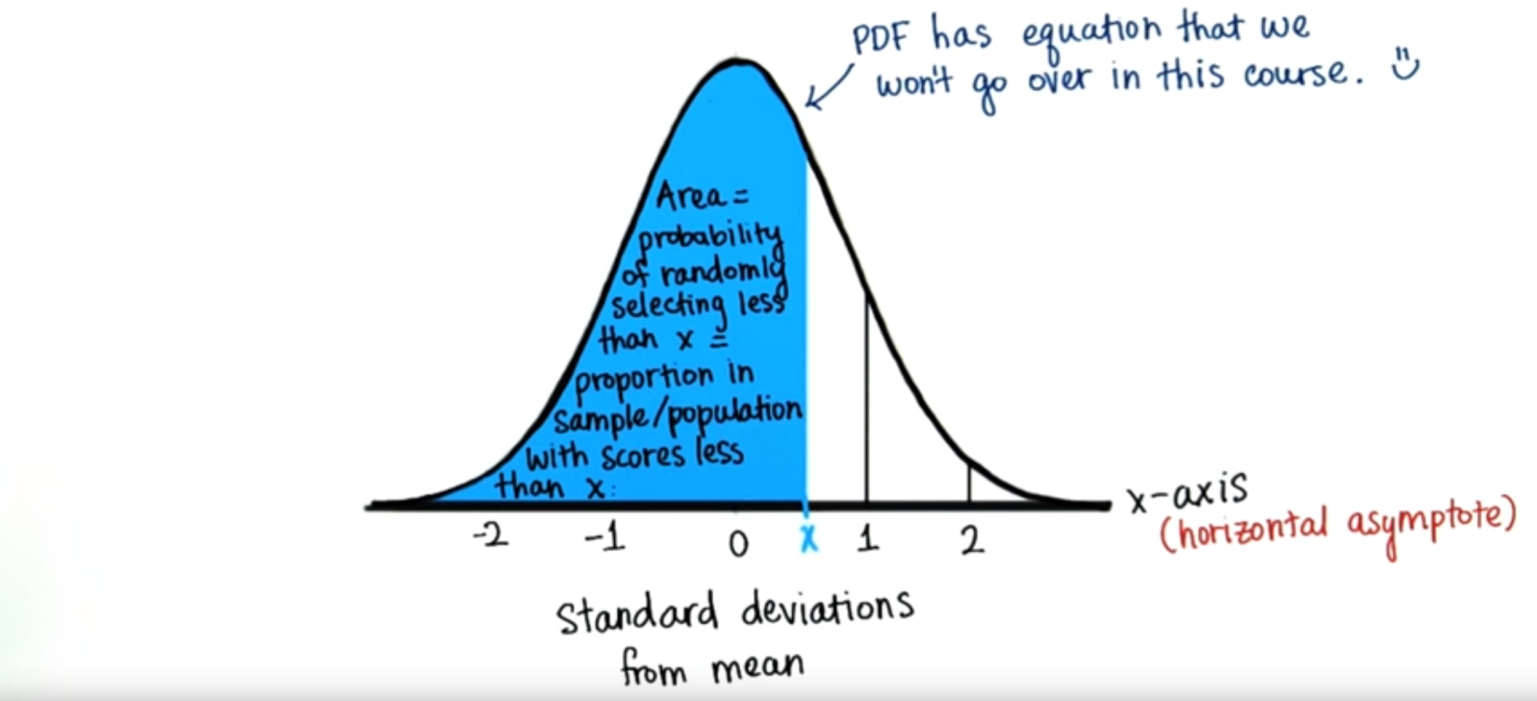
- Z-table:
→ when we have the z-score, the values in the tables tell us the proportion less than that z-score for the standard normal distribution;
→ use it to approximate the proportion less than a particular z-score

Links
- Z-table link: https://s3.amazonaws.com/udacity-hosted-downloads/ZTable.jpg

